**INTRODUCTION**

LiDAR, which stands for **Light Detection and Ranging**, is an advanced remote sensing technology that uses laser pulses to measure distances with exceptional accuracy. By emitting laser beams and analysing the time it takes for the reflected light to return, LiDAR systems create highly detailed, three-dimensional maps of the environment. This technology operates on the principle of measuring the speed of light and is capable of capturing millions of data points per second.

LiDAR has become a cornerstone in various industries due to its versatility and precision. It is widely used in **autonomous vehicles**, **geographic information systems (GIS)**, **environmental monitoring**, **urban planning**, **archaeology**, and **disaster management**, among other fields.

One of its key advantages is its ability to penetrate dense vegetation and provide accurate topographic information, making it invaluable for applications such as mapping forest canopies or flood plains. Additionally, LiDAR's high-resolution data enables the detection of subtle surface features that are often invisible to conventional imaging methods.

As the demand for smart and data-driven solutions continues to grow, LiDAR technology remains at the forefront, shaping the future of spatial analysis, automation, and scientific discovery.

**WORKING PRINCIPLES**

LiDAR operates based on the **Time-of-Flight (ToF)** principle, using laser pulses to measure distances by calculating the time taken for light to travel to a target and return to the sensor. The core process involves the following steps:

1. **Emission**: A LiDAR system emits a short laser pulse toward an object or surface.
2. **Reflection**: The laser pulse reflects off the object and returns to the LiDAR receiver.
3. **Time Measurement**: The system calculates the time difference between emission and reception of the pulse.
4. **Distance Calculation**: The distance to the target is computed using the formula:
5. **Data Integration**: These measurements are processed to generate a dense **point cloud**, which forms the basis of 3D spatial models.

**Key Components of a LiDAR System**

* **Laser Emitter**: Produces highly concentrated laser pulses.
* **Receiver/Sensor**: Captures the reflected laser signals.
* **Global Positioning System (GPS)**: Provides geolocation data for spatial accuracy.
* **Inertial Measurement Unit (IMU)**: Measures orientation and movement.
* **Data Processor**: Converts raw data into actionable formats such as 3D maps or models.

**Types of LiDAR Systems**

1. **Aerial LiDAR**: Mounted on drones, helicopters, or airplanes to survey large areas.
2. **Terrestrial LiDAR**: Ground-based systems used for detailed structural analysis.
3. **Mobile LiDAR**: Installed on vehicles for real-time data collection, often in dynamic environments.
4. **Bathymetric LiDAR**: Specialized systems for mapping underwater terrains.

**Graphical Representation of LiDAR Working**

Below is a graph representing the working principle of LiDAR:

* **X-Axis**: Distance (in meters)
* **Y-Axis**: Time of Flight (in nanoseconds)

The graph shows a linear relationship between the distance and the time taken by the laser pulse to return.

Let me generate a graph for better visualization.

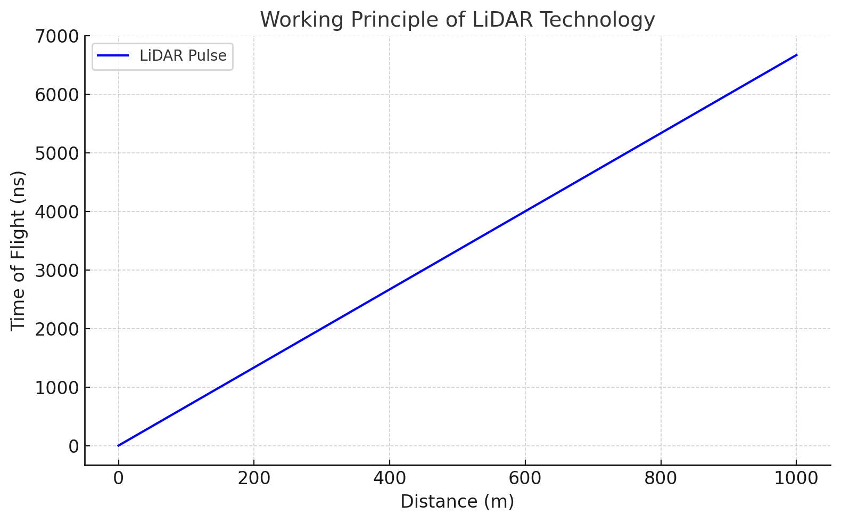

This graph illustrates the relationship between the distance to the target and the time of flight of the laser pulse in a LiDAR system. As the distance increases, the time of flight also increases proportionally. This relationship is the basis for LiDAR's ability to calculate distances accurately. ​​

**APPLICATIONS OF LiDAR TECHNOLOGY**

**Autonomous Vehicles**

* LiDAR serves as the "eyes" of autonomous vehicles, providing 360-degree environmental mapping.
* Enables real-time obstacle detection and navigation.
* Integrates with other sensors, such as cameras and radar, for enhanced decision-making.

**Environmental Monitoring**

* Assists in tracking deforestation, monitoring ecosystems, and mapping biodiversity.
* Analyses coastal erosion and maps flood-prone zones with high accuracy.
* Helps in climate change studies by monitoring glacier dynamics and sea-level rise.

**Urban Planning and Development**

* Facilitates precise infrastructure design, including roadways, bridges, and buildings.
* Enables smart city planning through accurate terrain and structural data.
* Supports disaster management by modelling potential impact zones.

**Archaeology**

* Uncovers hidden ruins and ancient sites obscured by dense vegetation.
* Preserves heritage by creating 3D digital replicas of historical sites.

**Precision Agriculture**

* Monitors crop health, soil conditions, and irrigation patterns.
* Enhances yield prediction models through spatial analytics.
* Identifies pest-infected zones and optimizes resource allocation.

**ADVANTAGES OF LiDAR TECHNOLOGY**

LiDAR technology offers several advantages, making it highly effective in various applications. Here are the key benefits:

1. **High Accuracy**:  
   LiDAR provides highly accurate distance measurements, with precision up to centimetres, which is crucial for detailed mapping and topographic surveys.
2. **Rapid Data Collection**:  
   LiDAR can collect large amounts of data in a short period, making it highly efficient for large-scale mapping projects such as forest management, urban planning, and infrastructure development.
3. **3D Mapping**:  
   LiDAR creates precise three-dimensional models of the surveyed area, which is useful for a wide range of applications, including topography, flood modeling, and geological studies.
4. **Penetrates Vegetation**:  
   LiDAR pulses can penetrate through trees and vegetation to map the ground beneath, providing valuable data in areas with dense vegetation or forests where traditional survey methods may struggle.
5. **High Resolution**:  
   LiDAR can produce high-resolution data, enabling the detection of small features and intricate details that might be missed by other surveying technologies.
6. **Ability to Capture Data in Challenging Environments**:  
   LiDAR is effective in environments with poor visibility, such as during nighttime, in fog, or in areas with heavy vegetation, where optical or GPS-based methods might not perform well.
7. **Cost-Effective**:  
   By reducing the time and labor required for manual data collection, LiDAR can significantly lower the overall costs of surveying and mapping large areas.
8. **Versatile Applications**:  
   LiDAR is used in various industries such as environmental monitoring, archaeology, forestry, urban planning, and autonomous vehicles for navigation and obstacle detection.
9. **Real-Time Data Processing**:  
   LiDAR systems can provide real-time data, which is useful for dynamic applications such as navigation systems in autonomous vehicles.
10. **Safety and Accessibility**:  
    LiDAR allows data collection from a distance, which can be advantageous in hazardous or hard-to-reach areas, ensuring safety while still obtaining critical information.

These advantages make LiDAR a powerful tool for both scientific and commercial purposes.

**LIMITATIONS OF LiDAR TECHNOLOGY**

While LiDAR technology offers many advantages, it also has some limitations:

1. **High Cost**:  
   LiDAR systems, both in terms of hardware and software, can be expensive, especially for high-precision equipment or large-scale projects, which may limit its accessibility for smaller operations.
2. **Dependence on Clear Weather**:  
   LiDAR performance can be affected by weather conditions such as heavy rain, snow, or fog. These elements can hinder the laser's ability to travel and reflect accurately, leading to data gaps or inaccuracies.
3. **Limited Range**:  
   LiDAR systems have a limited range depending on the power of the laser and environmental conditions. While some systems can scan several kilometers, others may struggle to measure large distances, especially in areas with complex terrain.
4. **Data Processing Complexity**:  
   The vast amount of data generated by LiDAR systems requires significant processing power and specialized software to interpret. This can lead to long processing times, and handling and storing such large datasets can be challenging.
5. **Surface Reflectivity Issues**:  
   LiDAR data accuracy can be affected by the reflectivity of the surface being scanned. For example, shiny surfaces (e.g., water bodies, glass, or wet surfaces) may not reflect the laser pulses efficiently, resulting in inaccurate data or no data capture.
6. **Limited Penetration in Some Environments**:  
   While LiDAR can penetrate vegetation, it has difficulty in densely packed areas, such as thick canopies or multi-layered vegetation, leading to incomplete ground-level data.
7. **Size and Portability**:  
   Some LiDAR systems, especially airborne ones, require large equipment or vehicles, which may limit their use in certain environments where portability is essential.
8. **High Power Consumption**:  
   LiDAR systems, particularly high-precision ones, tend to consume significant amounts of power, which can be an issue for mobile or remote operations unless proper power sources are available.
9. **Difficulties with Dynamic Objects**:  
   LiDAR may struggle to accurately capture fast-moving or dynamic objects, as the sensor may not have enough time to return a reliable reading for objects that are in motion.
10. **Data Density Issues**:  
    In sparsely populated areas or areas with low reflectivity, the data density captured by LiDAR sensors might be too low to produce highly detailed or reliable models.

Despite these limitations, LiDAR remains a valuable technology for many applications, especially when combined with other methods to enhance its capabilities.

**FUTURE PROSPECTS OF LiDAR TECHNOLOGY**

LiDAR technology holds promising potential for future advancements and applications across various industries. Some of the key future prospects include:

1. **Integration with Autonomous Vehicles**:  
   LiDAR is a critical technology for the development of self-driving cars. As autonomous vehicles require precise environmental mapping and obstacle detection, LiDAR's ability to create high-resolution 3D maps will continue to be essential for their navigation systems.
2. **Urban Planning and Smart Cities**:  
   With the rise of smart cities, LiDAR technology will play a major role in urban planning and infrastructure development. It can be used to create accurate 3D models for urban design, monitor structural integrity, and optimize traffic systems.
3. **Environmental Monitoring and Conservation**:  
   LiDAR is increasingly being used in environmental studies, such as monitoring forest health, measuring deforestation rates, and studying biodiversity. It can also help track climate change effects, such as sea level rise and changes in vegetation, by providing detailed data over time.
4. **Agriculture and Precision Farming**:  
   In agriculture, LiDAR can be used for precision farming to map terrain, monitor crop health, and optimize irrigation systems. By creating detailed topographic maps, it can help farmers make data-driven decisions that improve yield and resource management.
5. **3D Mapping and Virtual Reality**:  
   LiDAR technology is poised to enhance the creation of accurate 3D maps and virtual models for industries such as gaming, entertainment, and virtual tourism. It will enable more realistic and immersive environments for users by capturing real-world locations in high detail.
6. **Disaster Management and Response**:  
   LiDAR will be invaluable in disaster management by helping to assess damage after natural disasters such as earthquakes, floods, and hurricanes. Its ability to quickly generate precise topographic models of affected areas will aid in effective disaster response and recovery planning.
7. **Agricultural Drones and Robotics**:  
   The future of LiDAR includes integration with unmanned aerial vehicles (UAVs) and agricultural robots. This integration will allow for high-resolution, real-time data collection from the air, making land surveying, crop monitoring, and environmental assessments more efficient.
8. **Geospatial Data for Land Development**:  
   As land development and real estate projects continue to grow, LiDAR will be widely adopted for accurate topographic mapping, flood modeling, and land surveying. It will also be crucial for heritage preservation by capturing detailed 3D scans of historical sites and landmarks.
9. **Improvement in Miniaturization and Cost Reduction**:  
   As technology advances, we can expect LiDAR systems to become more compact, affordable, and energy-efficient. The development of lighter and cheaper LiDAR sensors will make it accessible for wider use, including mobile applications and consumer devices.
10. **Advancements in LiDAR for Healthcare and Biomedical Applications**:  
    LiDAR could have a future role in healthcare, such as mapping human tissues, diagnosing diseases, or creating more precise models for surgeries. Its applications in medical imaging could improve non-invasive diagnostic technologies.
11. **Integration with Artificial Intelligence (AI) and Machine Learning**:  
    The combination of LiDAR with AI and machine learning algorithms will enhance data processing and interpretation. This could lead to more accurate and real-time decision-making, particularly in dynamic environments such as transportation, robotics, and agriculture.

The future of LiDAR technology is bright, as its integration with new technologies, such as AI, drones, and autonomous systems, will continue to unlock new applications and enhance its utility across multiple industries.

**CONCLUSION**

LiDAR technology represents a paradigm shift in how we perceive and interact with spatial data. Its ability to capture high-resolution, 3D information in real time has made it a cornerstone in fields ranging from autonomous navigation to environmental science. While challenges such as cost and data processing remain, continuous advancements in technology promise to make LiDAR more accessible and versatile. As industries and researchers explore new applications, LiDAR is poised to redefine spatial analysis and contribute to solving global challenges.